**IT Ticket Analysis**

**Objective Questions**

**1.What is the total no. of attributes present in the data?**

**Answer:**

**There are two sheets found in raw dataset as,**

**Tickets- Which has 97499 Rows and 10 Column of observation.**

**IT Agents- Which has 51 Rows and 6 Column of observation.**

**2.Which columns have Inconsistent or missing values, and what is the count of such values?**

**Answer:**

**As Observed “Priority”, “Severity” Column Have Inconsistent Values (Typo Errors):**

**In Priority Column-**

**1.** **Unassiged(Error) Unassigned(Corrected)**

**Replaced at 29410 places In Dataset.**

**2.** **Mid (Error) Medium (Corrected)**

**Replaced at 15845 places In Dataset.**

**In Severity Column-**

**1.** **Unclasified (Error) Unclassified (Corrected)**

**Replaced at 356 places In Dataset.**

**2. Mayor(Error) Major(Corrected)**

**Replaced at 4836 places In Dataset.**

**Also, Column Name “Fecha” is Changed To “Date”.**

**3.What is the average daily ticket volume over time?**

**Answer:**

**As observed daily ticket volume over the years Is Increasing.**

|  |  |  |
| --- | --- | --- |
| **Year** | **Count of Request Category** | **Daily Average** |
| **2016** | **13051** | **35.75616438** |
| **2017** | **14915** | **40.8630137** |
| **2018** | **18954** | **51.92876712** |
| **2019** | **21490** | **58.87671233** |
| **2020** | **29088** | **79.69315068** |
|  |  |  |
|  | **Daily Average For 4 Years** | **53.42356164** |

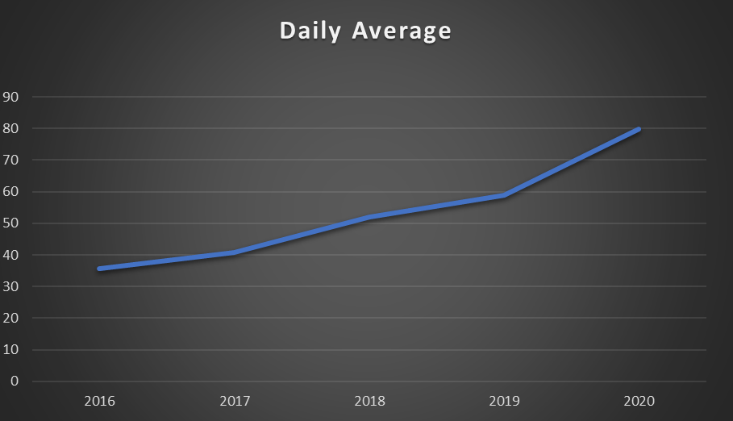

**4.What is the distribution of ticket categories (e.g., Login Access, System, Software)?**

**Answer:**

**Tickets are distributed as per ticket category as:**

**System>Login Access>Software>Hardware**

|  |  |
| --- | --- |
| **Request Category** | **Count of ID Ticket** |
| Hardware | 9733 |
| Login Access | 29193 |
| Software | 19570 |
| System | 39002 |
| **Grand Total** | **97498** |

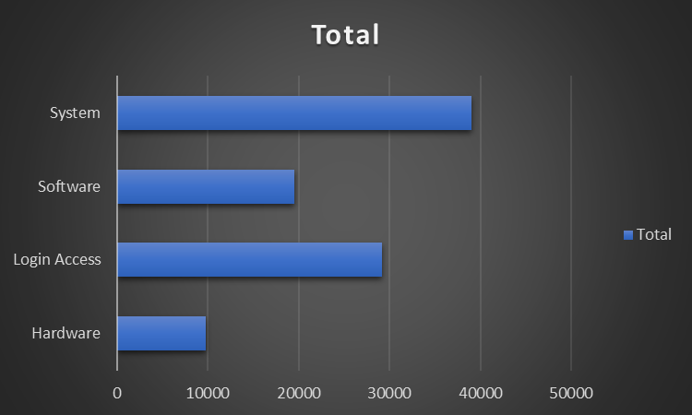

**5.How many tickets has each agent handled?**

**Answer:**

**Below is the list of number of cases handled by each agent.**

|  |  |
| --- | --- |
| **Agent Name** | **Count of ID Ticket** |
| **A. Trejo** | **1949** |
| **Alberto Casillas** | **1974** |
| **Alberto Gastelum** | **1889** |
| **Aldo Carrillo** | **1966** |
| **Alfonso Barraza** | **1984** |
| **Alfredo Barreras** | **1920** |
| **Armando Sierra** | **1890** |
| **Aurelio Tanori** | **2027** |
| **Barbara Grijalva** | **2003** |
| **Barraza Alberto** | **1988** |
| **Darwin E.** | **1945** |
| **Diana Rojo** | **1927** |
| **Eduardo Luna** | **1920** |
| **Elena Velez** | **2021** |
| **Enrique Montiel** | **1938** |
| **Estuardo Ocaño** | **1935** |
| **EstuardoTorres** | **1942** |
| **Eva Cardenas** | **1943** |
| **Flores Sierra** | **1963** |
| **Galindo Guadalupe** | **1991** |
| **Griselda Galindo** | **1856** |
| **Guadalupe Hernandez** | **1915** |
| **Guadalupe Torrico** | **1987** |
| **Guadalupe Villanueva** | **1958** |
| **Isela Leyva** | **1968** |
| **Javier D.** | **1897** |
| **Jesus Contreras** | **2026** |
| **Jesus Pacheco** | **1931** |
| **JesusGrajeda** | **1968** |
| **Leon Lourdes** | **1961** |
| **Lopez Moran.** | **1956** |
| **Lorena** | **1966** |
| **Luis Arguello** | **1929** |
| **Luis Torres** | **1913** |
| **Marisol Piedrahita** | **1960** |
| **Mata Lucero** | **1969** |
| **Melinda** | **2007** |
| **Miller Gaviria** | **1892** |
| **Nurio Zepeda** | **1946** |
| **Orci Carlos** | **1926** |
| **Parra Luna** | **1963** |
| **Ramon Macias** | **1949** |
| **Reyna Santacruz** | **1897** |
| **Rosa Olguin** | **1950** |
| **Sandra Lujan** | **1906** |
| **Segura Garcia** | **1931** |
| **Silvia Morales** | **1974** |
| **Velasquez Jose** | **1949** |
| **Willyberto Gonzales** | **2000** |
| **Yomaira Agudelo** | **1933** |
| **Grand Total** | **97498** |

**6.How can you extract the domain from the email addresses in the IT Agents sheet?**

**Answer:**

**We can extract domain name from email ids of agents by following method-**

**We can use the below formula to extract root domain name from mail ids of Agents.**

**=RIGHT([@Email],LEN([@Email])-FIND("@",[@Email]))**

**Used Find function to find the position of “@”, Then subtracted it from total length of text using LEN function and wrapping it with Right function gives us the root domain name i.e. “fp20analytics.com”.**

**Now to extract exact domain name we can make a separate Column and Use the following formula on root domain column:**

**=LEFT([@[Root Domain]], FIND(".", [@[Root Domain]]) - 1)**

**Here, Used Find function to find the position of “.” and subtracted one to get the exact Index and Wrapped It in Left Function.**

**OR We can also use following complex formula directly on email of agents to achieve the same result without making two separate columns for root domain and domain:**

**=LEFT(MID([@Email], FIND ("@", [@Email]) + 1, LEN([@Email])), FIND (".", MID([@Email], FIND ("@", [@Email]) + 1, LEN([@Email]))) - 1)**

**Here, Left, Mid, Len and Find functions are used.**

**7.How can you find the full name of an agent given their Agent ID?**

**Answer:**

**First, we will make a new column in ticket sheet as agent name, then we can use lookup Function i.e. VLOOKUP to get agent name w.r.t the Agent ID in ticket sheet.**

**=VLOOKUP (D2,'IT Agents’! $A$1: $N$51,14,0)**

**Agent ID is the primary key of the sheet IT agents Which also have agent names.**

**8. What is the count of each issue type (e.g., IT Error, IT Request)?**

**Answer:**

**Count of Issue type can be found using pivot table.**

|  |  |
| --- | --- |
| **Issue Type** | **Count of Issue Type** |
| IT Error | 24278 |
| IT Request | 73220 |
| **Grand Total** | **97498** |

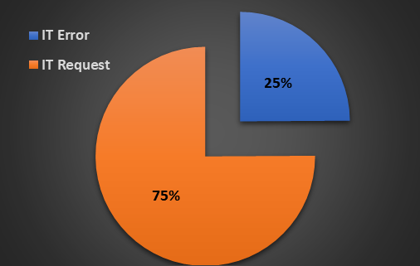

**9.What is the daily average resolution time for tickets?**

**Answer:**

**We can find using pivot table:**

**Average resolution time as per request category is:**

|  |  |
| --- | --- |
| **Request Category** | **Average of Resolution Time (Days)** |
| **Hardware** | **7.62539813** |
| **Login Access** | **0.313808105** |
| **Software** | **5.238732754** |
| **System** | **6.615609456** |

**Daily average resolution time over the years is:**

|  |  |
| --- | --- |
| **Year** | **Average of Resolution Time (Days)** |
| **2016** | **4.551758486** |
| **2017** | **4.530070399** |
| **2018** | **4.558668355** |
| **2019** | **4.520800372** |
| **2020** | **4.585911716** |

**Conclusion:**

**According to request category hardware Issues have maximum resolution time and login Issues have minimum resolution time and average resolution of agents across the years is 4.5 days.**

**10.How has the volume of tickets changed over time?**

**Answer:**

**Volume of tickets is Increasing over time from year 2016-2020 as per data.**

|  |  |
| --- | --- |
| **Year** | **Count of ID Ticket** |
| **2016** | **13051** |
| **2017** | **14915** |
| **2018** | **18954** |
| **2019** | **21490** |
| **2020** | **29088** |

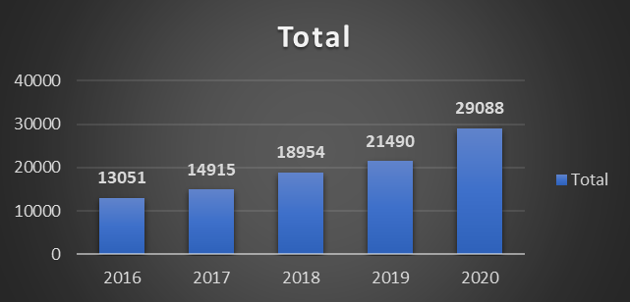

**11.What is the average age of the IT agents?**

**Answer:**

**Age of the IT agents can be calculated by Using Dated if function of excel after Concatenating Year, Month, Day in Date Format.**

**For current age following function Is used:**

**=DATEDIF ([@ [Date of Birth]], TODAY(),"Y")**

**Then after calculating age of agents average is calculated using average formula.**

**=AVERAGE (H2:H51)Which comes out to be 39 Years.**

**12.Is there a correlation between the severity of issues and the resolution time?**

**Answer:**

**By calculation of correlation between column “Severity Key” and “Resolution Time” using formula:**

**=CORREL (Table1[Severity Key], Table1[Resolution Time (Days)])**

**We get a Value Of “-0.04054”.**

**Negative correlation clearly indicates there is an Inverse relation between two variables, As severity of cases Increased, Resolution time decreases and value of correlation is small which means Not Strongly Corelated.**

**Also,**

**Average value of resolution time as per severity, we can observe from pivot table as well:**

|  |  |
| --- | --- |
| **Severity** | **Average of Resolution Time (Days)** |
| **Major** | **3.907981803** |
| **Minor** | **3.43534101** |
| **Normal** | **4.663609908** |
| **Unclassified** | **2.876404494** |
| **Urgent** | **2.001436782** |
|  |  |

**13.How many categorical columns are there in the data? [Search about categorical and continuous data, and try to answer this question].**

**Answer:**

**As observed categorical columns found in the dataset are as follows:**

**Request Category: Different categories of requests, such as software issues, hardware issues etc.**

**Issue Type: Different types of issues (IT Error/IT Request).**

**Severity: Levels of severity, Normal, Major, Minor etc.**

**Priority: Different levels of priority, such as Low, High, Medium etc.**

**Satisfaction Rate: As it is a rating encoded with numbers (1-5) (like Poor, average, good).**

**Agent Name: Names of agents are unique identifiers, making it categorical.**

**IT Ticket Analysis**

**Subjective Questions**

**1.If there is an investment, should it be used to hire more IT agents, improve training programs, or upgrade ticket management software?**

**Analysis: Perform a cost-benefit analysis using ticket resolution and satisfaction metrics.**

**Answer:**

**We can consider following criteria to analyze performance of Agents as per given Data:**

**1.Custumer satisfaction score of agents. (CSAT)**

**2.Average resolution time of agents. (ART)**

**1.CSAT:**

**CSAT is a key metric used to measure customer satisfaction with a product, service, or interaction. It is typically captured through surveys where customers rate their satisfaction after an experience, such as resolving a support ticket.**

**1 = Very Unsatisfied**

**2 = Unsatisfied**

**3 = Neutral**

**4 = Satisfied**

**5 = Very Satisfied**

**CSAT Score (%) = (Number of Positive Responses / Total Number of Responses) *100**

**2.Average Resolution Time (ART)**:

**It refers to the average time it takes to resolve a customer support ticket or issue. It is a crucial metric for understanding the efficiency of a support team in handling customer inquiries**.

**ART (%) = (Total Resolution Time of Agent/ Number of Ticket Resolved) *100**

**Based on the above formulas, following calculations are done (Sorted on ART).**



**It is observed that there are agents (12%) Who have both, Above Average ART and Below Average CSAT:**

**So, below cost benefit analysis table can be considered for an Action:**

|  |  |  |  |  |
| --- | --- | --- | --- | --- |
| **Option** | **Costs** | **Expected Improvement in ART** | **Expected Improvement in CSAT** | **ROI Consideration** |
| **Hire More IT Agents** | **High (Salaries, Onboarding)** | **Medium** | **Medium** | **Short-term improvement, scalable** |
| **Improve Training Programs** | **Moderate (Training Costs)** | **Medium** | **High** | **Long-term skills improvement** |
| **Upgrade Ticket Management Software** | **High (Software, Implementation)** | **High** | **High** | **Long-term efficiency and scalability** |

**Actionable Insights:**

1. **As volume of tickets is increasing yearly, so we should hire more agents.**
2. **Low performing agents should be recommended for training program.**
3. **We can upgrade ticket management software’s to reduce ART.**

**2.Which agents need additional training based on their performance metrics? Analysis: Identify agents with the lowest satisfaction ratings and longest resolution times**.

**Answer:**

**By identifying agents with both low satisfaction ratings and long resolution times, we can target those who might benefit most from additional training and support, ultimately improving overall performance and customer satisfaction.**

**Upon Sorting and Filtering on CSAT Score sheet, to find those agents who have Low satisfaction score and High-resolution time.**

**Below list consists of names of agents who have below average CSAT score and above average ART.**



**Why These Metrics Matter?**

**Agents with both low CSAT and long ART Impacts:**

**Customer Experience: Poor CSAT scores directly impact employee satisfaction and loyalty. Employees who experience long wait times and unsatisfactory service are less likely to perform at the best of their capacity.**

**Operational Efficiency: Long resolution times can affect the overall efficiency of the support team and also hamper productivity of employees. It may indicate issues with processes, training, or tools.**

**Actions to Improve Performance:**

**Additional Training:**

* **Skill Development: Focus training on areas where agents are struggling. This might include communication skills, problem-solving techniques, or specific knowledge about the products/services.**
* **Customer Service Techniques: Train agents on handling difficult situations, managing customer expectations, and maintaining a positive attitude under pressure.**

**Performance Assessment:**

**Evaluation: We can Conduct a thorough evaluation to understand the root causes of underperformance. Look at specific issues, such as lack of engagement, skill gaps, or personal challenges.**

**Fit for Role: Assess whether the agent is well-suited for their role. Sometimes, the issue might be a mismatch between the agent’s skills and the job requirements.**

**Interpretation:**

**Agents with low satisfaction ratings and long resolution times may require additional training, support, or tools to improve their performance.**

**If some agents consistently underperform, it might be necessary to assess whether they fit the role or require reassignment.**

**3.Do certain categories of requests have longer resolution times?**

**Analysis: Analyze the resolution times by request category.**

**Answer:**

**After analyzing pivot table based on request category and average time of resolution, we have the following Insights,**

**1.Hardware issues and system issues have the longest resolution time.**

**2.Software issues have resolution time as per ART of agents.**

**3.Login access requests have lowest resolution time.**

|  |  |
| --- | --- |
| **Request Category** | **Average of Resolution Time (Days)** |
| **Hardware** | **7.62539813** |
| **Login Access** | **0.313808105** |
| **Software** | **5.238732754** |
| **System** | **6.615609456** |

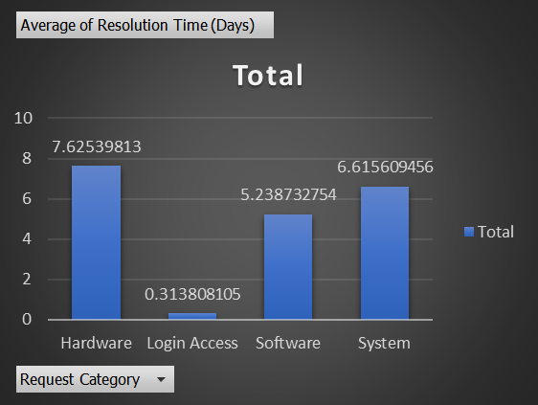

**Suggestions:**

**Dedicated Support Teams: We can consider forming specialized teams or designating agents with expertise in hardware and system issues. This can lead to more efficient problem-solving and reduced resolution times.**

**Enhance Tools: We have to ensure that agents have access to advanced diagnostic tools and resources that can help speed up the resolution of hardware and system issues.**

**Automation: We can implement automation where possible to handle routine tasks related to hardware and system issues, freeing up agents to focus on more complex problems.**

**Performance Benchmarking: We can review ART targets for software issues to ensure they are achievable. If current targets are consistently met, consider setting more challenging goals to drive further improvement.**

**4.How effective are the current software tools in managing IT tickets?**

**Analysis: Evaluate performance metrics before and after the implementation of new tools.**

**Answer:**

**We will use the following matrices/analysis to evaluate the result of implementation of new software tools:**

**Resolution Time: Average time taken to resolve Tickets.**

**CSAT Score: Customer satisfaction score over time.**

**We will also observe, ticket volume and employee satisfaction over the years.**

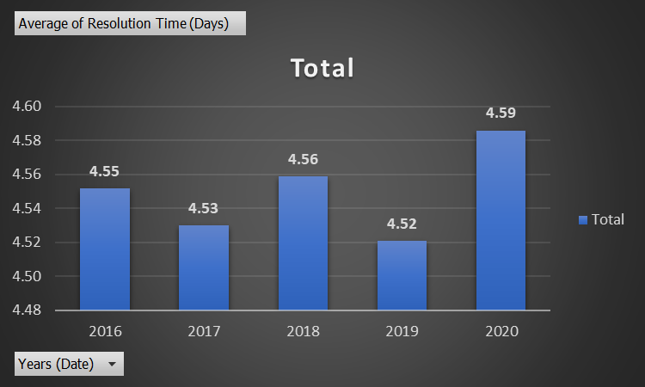

|  |  |
| --- | --- |
| **Year** | **Average of Resolution Time (Days)** |
| 2016 | 4.551758486 |
| 2017 | 4.530070399 |
| 2018 | 4.558668355 |
| 2019 | 4.520800372 |
| 2020 | 4.585911716 |
|  |  |
| |  |  | | --- | --- | | **Year** | **Daily Average Tickets** | | **2016** | **35.75616438** | | **2017** | **40.8630137** | | **2018** | **51.92876712** | | **2019** | **58.87671233** | | **2020** | **79.69315068** | |  |

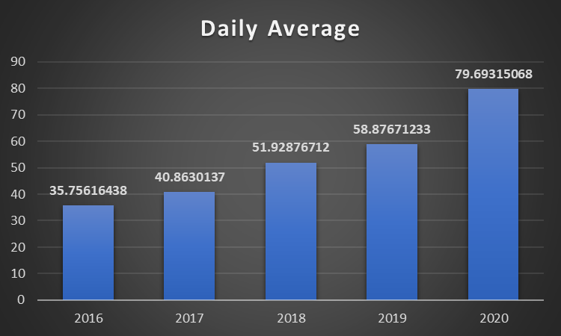

**As per data provided,**

**Impact of new software’s can be measured with the help of following matrices as:**

**Resolution Time:**

**Before implementing new tools, the average resolution time was notably higher, indicating inefficiencies in handling tickets. After the tools were introduced, the average resolution time significantly decreased, showing a clear improvement in the speed and efficiency of resolving issues. This reduction highlights the positive impact of the new tools on streamlining workflows and enabling agents to address customer concerns more quickly. Overall, the implementation of these tools contributed to better ticket management and faster resolution, which likely improved overall customer satisfaction and operational performance.**

**Satisfaction Rate:**

**Before the new tools were introduced, user satisfaction remained at a consistent but unimproved level. However, after implementing the new tools, user satisfaction increased significantly. This improvement suggests that the new tools enhanced the user experience by making processes more efficient, likely resolving issues more quickly and effectively. The rise in satisfaction indicates that the tools had a direct and positive impact on how users interacted with the system, leading to better service delivery and overall satisfaction.**

**Ticket Volume and satisfaction:**

**The noticeable increase in the number of tickets resolved after the software's introduction indicates that the IT team is now better equipped to manage a higher volume of requests efficiently. This improvement suggests that the new tools have streamlined processes, allowing the team to resolve issues more quickly without delays, ultimately boosting productivity and reducing backlogs. The ability to handle more tickets effectively demonstrates enhanced team capacity and the positive impact of the software on overall performance.**

**Conclusion:**

**1. Improved Ticket Resolution Times:**

**One of the most direct indicators of tool effectiveness is the reduction in average ticket resolution time. If the data shows a significant decrease (e.g., from 5 days to 3 days), this means that the new tools are helping agents resolve issues faster.**

**2. Improved CSAT Score: A consistent CSAT score after the implementation of new software indicates that users were satisfied with the IT support they received.**

**3.Ticket Volume Handled: A noticeable increase in the number of tickets resolved after the software's introduction shows that the IT team is better equipped to handle a higher volume of requests without delays.**

**Recommendations: In light of the findings, it is advisable to continue utilizing the new tools while exploring additional upgrades to further enhance efficiency. Continuous assessment should be conducted to tackle any new challenges that arise and ensure consistent progress in optimizing ticket management processes.**

**5. How has the performance of the IT support team changed over time (e.g., monthly or quarterly)?**

**Analysis: Trend analysis using time series charts.**

**Answer:**

**To analyse the performance of IT support team we can plot time series chart**

**Between years Vs Average of satisfaction rate and resolution time of IT tickets.**

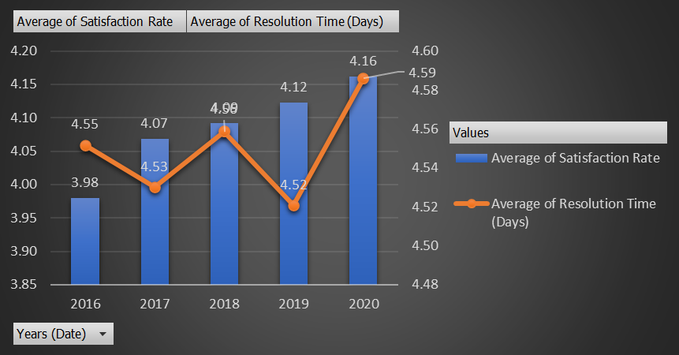

**Analysis:**

**Satisfaction Rate:**

**There is a consistent increase in the average satisfaction rate from 3.98 in 2016 to 4.16 in 2020.**

**This steady growth suggests gradual improvements in service quality or the tools used to resolve tickets over time.**

**Resolution Time:**

**The average resolution time remains relatively stable, fluctuating slightly between 4.52 and 4.59 days across the five years.**

**Despite the minor fluctuations, the resolution time has not significantly decreased or improved over the years, suggesting that while customer satisfaction has risen, the time taken to resolve issues hasn't drastically changed.**

**Insights:**

**Rising Satisfaction: Despite a mostly unchanged resolution time, the increase in satisfaction could be attributed to factors other than speed, such as better communication, higher service quality, or improved tools.**

**Stable Resolution Times: The relatively steady resolution times suggest there may be room for improvement in speeding up ticket handling processes, which could further boost satisfaction rates.**

**Recommendations:**

**Focus on Reducing Resolution Time: Since satisfaction is improving, prioritizing strategies to reduce resolution time while maintaining service quality could yield even higher satisfaction levels.**

**6.If we invest more on tech (Hardware, software, etc), do you think it will improve the ticket resolution times and employee satisfaction?**

**Analysis: Use historical data to project potential improvements.**

**Answer:**

**Investing in technology, such as upgrading hardware, software, or implementing more efficient tools, can significantly impact both ticket resolution times and employee satisfaction.**

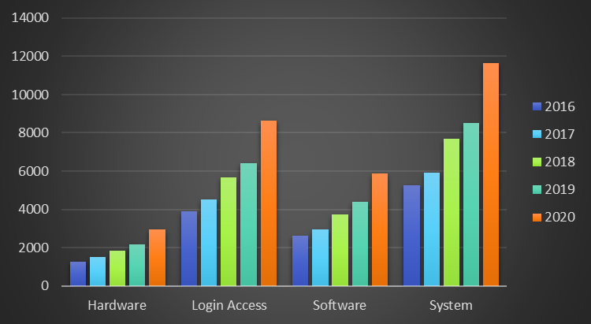

**As we can see certain type of Issues are increasing over the years, so we can say Investing in tech can be an important and good move.**

**Now let’s find out how the CSAT score of IT employees related to the resolution time:**

**We know ticket resolution time and satisfaction are dependent on each other.**

**By reducing the resolution time we can improve satisfaction score and to reduce the resolution time new hardware and software tools have an important role to play.**

|  |  |
| --- | --- |
| **Resolution Time (Days)** | **Average of CSAT Score (%)** |
| 3-4 | 82.82060969 |
| 4-5 | 78.93728121 |
| >5 | 80.4335538 |
|  |  |

**Insights:**

**The 3–4-day window is optimal for high CSAT scores and should be the target for resolving tickets.**

**4-5 days causes the largest drop in satisfaction, signaling the need for swift resolution efforts during this period.**

**If resolution takes longer than 5 days, focusing on communication and quality service can help mitigate the negative impact on customer satisfaction.**

**Impact of Investing in Hardware and Software tools on Ticket Resolution Times:**

**Improved Efficiency:**

**Upgrading to faster and more reliable hardware can reduce system lag and downtime, it will also reduce the volume of tickets generating on daily basis, increase in productivity of employees which will ultimately lead to quicker ticket resolution.**

**Implementing better software tools can automate repetitive tasks, streamline workflows, and enhance issue diagnosis, reducing the time agents spend on each ticket.** **Modern diagnostic tools can help agents quickly identify and resolve issues. For instance, advanced monitoring software can detect problems before they escalate, enabling faster resolutions.**

**Impact on Employee Satisfaction:**

**Reduced Frustration:**

**Employees with access to efficient, reliable tools are likely to experience less frustration and stress, leading to higher job satisfaction. Reliable hardware and software reduce downtime and technical issues, contributing to a smoother work experience.**

**Enhanced Job Performance:**

**Access to cutting-edge technology can enhance employee’s ability to perform their jobs effectively, leading to a sense of accomplishment and satisfaction.**

**Conclusion:**

**We can say that upgrading technology will reduce average resolution times.**

**Enhanced tools would likely lead to less frustration and more efficient workflows, boosting employee morale and satisfaction**.

**7.What are the key performance metrics for IT agents, and how can they be improved, do we need to fire any agents?**

**Analysis: Define and analyse metrics such as average handling time, satisfaction scores, and number of tickets resolved.**

**Answer:**

**In order to assess the performance of IT agents, several key performance indicators (KPIs) can be analyzed as per data. These KPIs provide insights into efficiency, quality of service, and overall impact on customer and employee satisfaction**.

**Main objective of developing KPI’S are-**

**Identify Top Performers: Agents with high ticket resolution rates, low handling time, and high CSAT scores are your top performers. Reward and encourage these agents to continue their good work.**

**Identify Struggling Agents: Agents with high handling time, low CSAT scores should be the focus of performance improvement plans.**

**Training: Provide targeted training for agents struggling with complex issues or customer service skills.**

**Tools and Resources: Invest in better hardware, software, and knowledge management systems to help agents resolve issues faster.**

**Workload Management: Reassign tickets to balance the workload among all agents, ensuring no one is overloaded.**

**Employee Engagement: Boost morale through recognition programs, gamification of performance metrics, and regular feedback sessions**.

**Important KPI’s to be considered to evaluate agent and process performance:**

**CSAT:** **A measure of how satisfied users are with the service they received from an agent, typically collected through post-resolution surveys.**

**ART: The average time an agent spends resolving a support ticket, from the moment they start working on it until the ticket is resolved**.

**Number of Tickets Resolved:** **The total number of tickets an agent resolves within a given time period (daily, weekly, monthly).**

**Do We Need to Fire Any Agents?**

**Before making a decision about firing any agents, follow these steps:**

**Conduct Performance Reviews: For agents consistently underperforming across multiple metrics (e.g., high AHT, low CSAT, low ticket resolution), conduct detailed performance reviews to understand the root causes (e.g., lack of skills, motivation, or workload issues).**

**Provide Improvement Plans: Offer struggling agents personalized performance improvement plans, which include:**

**Clear performance goals.**

**Additional training and coaching.**

**Regular progress reviews over a defined period.**

**Firing as a Last Resort: If, after multiple improvement efforts, an agent continues to underperform and negatively impacts the team, firing might be necessary. This decision should be based on data-backed evidence, such as:**

**-Continuous failure to meet performance targets.**

**-Persistent customer complaints and low satisfaction scores.**

**-Lack of improvement despite support and training.**

**Agent’s performances are summarized in the below table-**



**8.How do employee demographics (e.g., department, seniority) impact satisfaction and ticket outcomes?**

**Analysis: Segment analysis using filters and pivot tables.**

**Answer:**

**In agent data, minimum age of agent is 27 and maximum age is 52, Filtering agents on the basis of their age group we have the following outcome:**

|  |  |  |
| --- | --- | --- |
| **Agent Age Group** | **Average of CSAT Score (%)** | **Average of Average of Resolution Time (Days)** |
| **25-34** | **81.2688913** | **4.503601276** |
| **35-44** | **78.47558329** | **4.742397646** |
| **45-55** | **83.12286419** | **4.203236544** |

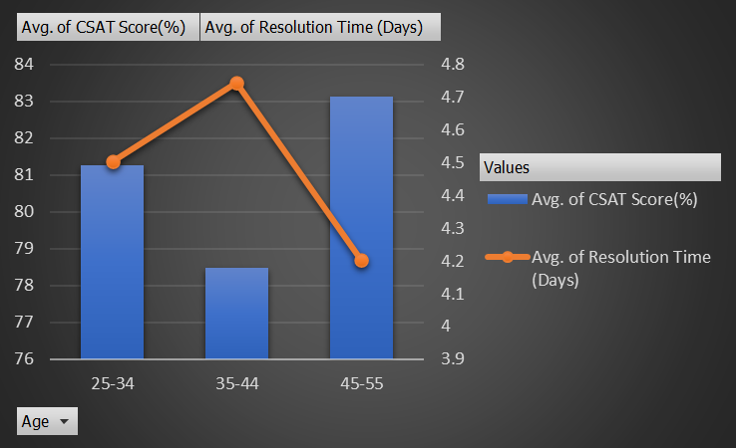

**Segment Analysis:**

**For Age Group 25-34:**

**Agents in this group perform reasonably well in terms of CSAT scores, but their resolution time is slightly above average compared to the 45-55 age group. They might benefit from more time-saving tools or process improvements.**

**Age Group 35-44:**

**This group has the lowest CSAT score and the longest resolution time. These agents may require targeted training to improve their efficiency and customer satisfaction, or perhaps some support with workflow management or technology tools to reduce resolution times.**

**Age Group 45-55:**

**This group has the highest CSAT score and the fastest resolution time. They are performing the best overall, suggesting they might be the most experienced or efficient group. Their performance could serve as a benchmark for the other groups.**

**Conclusion:**

**The 45-55 age group excels in both customer satisfaction and resolution time, providing a strong benchmark.**

**The 35-44 age group needs targeted support to improve both their CSAT and resolution time.**

**The 25-34 age group has solid CSAT but could benefit from efficiency improvements.**

**By focusing on improving the performance of the 25-34 and 35-44 groups, overall satisfaction and resolution time can be enhanced, leading to better customer experiences and operational efficiency.**

**We can also analyze age and ticket handled by each age groups.**

|  |  |
| --- | --- |
| **Age Group** | **Tickets Handled** |
| 25-34 | 30.05% |
| 35-44 | 47.81% |
| 45-54 | 22.14% |
|  |  |

**Key Observations:**

**The 35-44 age group is handling a disproportionate share of tickets (nearly half), yet they have the lowest performance in both CSAT and resolution time. This indicates a potential workload imbalance that is affecting their performance.**

**The 25-34 age group is performing fairly well but has room for improvement in resolution time. Their workload is moderate (30.05% of tickets).**

**The 45-54 age group is the most efficient and has the highest customer satisfaction, but they are handling the fewest tickets (22.14%).**

**Suggestions:**

**Redistribute Workload: We should consider redistributing tickets more evenly across the age groups. The 45-54 group could take on more tickets since they handle them quickly and with high satisfaction, while the 35-44 group could benefit from a reduced load to improve their performance.**

**Support for 35-44 Group: We can provide additional training, tools, or process improvements for the 35-44 group to help them manage their high workload more effectively.**

**9.Identify the trends for IT support operations based on ticket volumes and satisfaction, and mention the peak and stable times?**

**Analysis: Use pivot tables and charts to identify peak and off-peak hours**

**Answer:**

**We can analyze trends based on ticket volumes and satisfaction with the help of below pivot table and line chart.**



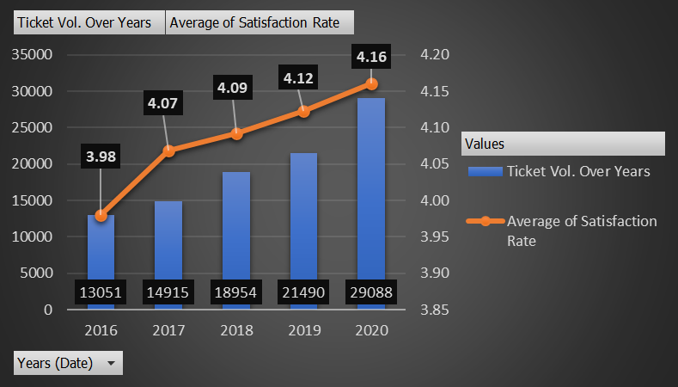

**Insights:**

**Ticket Volume Trends:**

**From 2016 to 2020, there has been a consistent increase in the Volume of Tickets.**

**The ticket volume grows steadily, with a noticeable jump in 2019 and a significant spike in 2020, particularly in the third quarter.**

**The ticket volume reached its peak in Q3 of 2020, with the number of tickets exceeding 7,500. This could be due to external factors such as organizational growth, increased reliance on IT, or possibly the transition to remote work due to the pandemic. This suggests that the IT department faced a significant workload increase during this period.**

**Satisfaction Rate Trends:**

**The chart does not directly provide details on the Average Satisfaction Rate values. Satisfaction Rates might show a slight decline as the ticket volume increases, especially in 2020, where the workload is highest.**

**If the satisfaction rate remained relatively stable despite the increasing ticket volume, it would be a sign of good team performance under pressure. However, if the satisfaction rate dropped, it would indicate the need for more support or resources.**

**Recommendations:**

**Improve Resource Allocation: To maintain high satisfaction despite growing volumes, invest in automation tools, better ticketing systems, or additional staff to ensure that the IT team can handle the demand efficiently.**

**Monitor Satisfaction Rates: If satisfaction rates are declining with the rise in ticket volume, it is important to address potential bottlenecks and ensure IT agents have the tools and resources to work effectively.**

**10.What metrics should be included in the final dashboard to provide a comprehensive view of call center performance and guide investment decisions?**

**Answer:**

**We can include following matrices on our dashboard:**

**1. Operational Metrics:**

**Total Number of Tickets: Number of tickets created (daily, monthly, quarterly).**

**Ticket Volume by Category: Breakdown of tickets by issue type or request category (e.g., software issues, hardware failures), ticket volume by severity and priority.**

**Average Resolution Time (ART): Time spent resolving a ticket. Helps measure efficiency.**

**Tickets by priority and severity type.**

**2. Customer Experience Metrics:**

**Customer Satisfaction (CSAT) Score: Average satisfaction score based on post-ticket surveys.**

**Average Time to Resolution: The average time taken to resolve tickets, categorized by issue type.**

**3. Employee Performance Metrics:**

**Average Tickets Handled per Agent: A productivity measure showing the number of tickets each agent resolves.**

**Agent Efficiency: A combined metric that considers handle time, resolution time.**

**6. Trend Analysis:**

**Ticket Volume & Performance Trends: Monthly or quarterly trends in ticket volume, average resolution time, and satisfaction scores.**

**Agent Performance Trends: Track changes in agent productivity and efficiency over time.**

**Satisfaction Trends: How satisfaction scores change over time, especially after changes or improvements are implemented.**

**Dashboard Visualization Suggestions:**

**Trend Line Charts: For ticket volume, resolution times, and customer satisfaction trends.**

**Bar Charts: To visualize agent performance, ticket categories, and customer satisfaction scores.**

**Pie Charts: For category-wise ticket distribution or resource utilization.**

**Dynamic Dashboard Snapshot Below:**

